Matthew Commerford PSVCK3944

The following document contains the documentation for the AYIG Connect App. This is related to the Android development assignment.

Documentation

ITADA4-B34 Assignment

Table of Contents

Purpose of this document 2

Technology used 2

Step-By-Step walkthrough Of The Application 2

Login Page: 2

Register Page: 3

Affiliate Page: 4

Update Page: 5

Admin Page: 6

Change user role page: 7

Post Update Page: 9

9

9

Code Snippets 11

Login And Registration Module 11

Affiliate Module: 13

Admin Module: 15

Change User Role Activity 16

Post Event Activity 17

Update Credentials Activity 18

18

Firebase: 19

Authentication 19

19

Database 20

Users table 20

20

Posts table 20

20

# Purpose of this document

The purpose of the following document is to document the Android development project. The document will contain screenshots showcasing a step-by-step explanation of the application that was designed. Along with these screenshots there will also be short explanations of what is happening. Screenshots of code snippets and the database will also be added along with explanations.

# Technology used

Below are listed the technology stack that were used in order to development this application:

* Android studio
* Java
* Firebase
* Firebase Authentication
* Firestore for the database

# Step-By-Step walkthrough Of The Application

The following section will be used to take the user through a detailed walkthrough of how the application works and how to use it.

## Login Page:

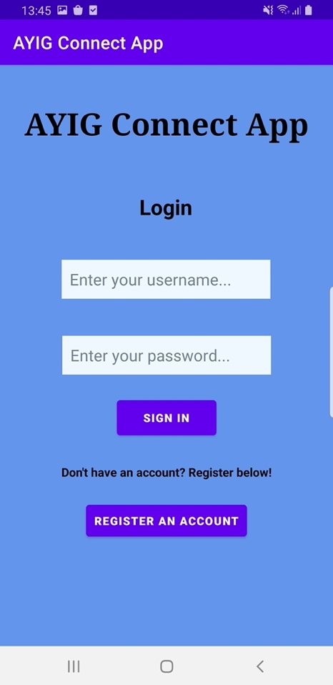

When the user opens up the app they are presented with a login screen which can be seen in figure 1. Here the user has the options to:

* Enter their login details and login to the application.
* If the user does have an account, they can register for application by creating a free account by clicking on the “Register an account” button.

**Figure 1) Login Page**

## Register Page:

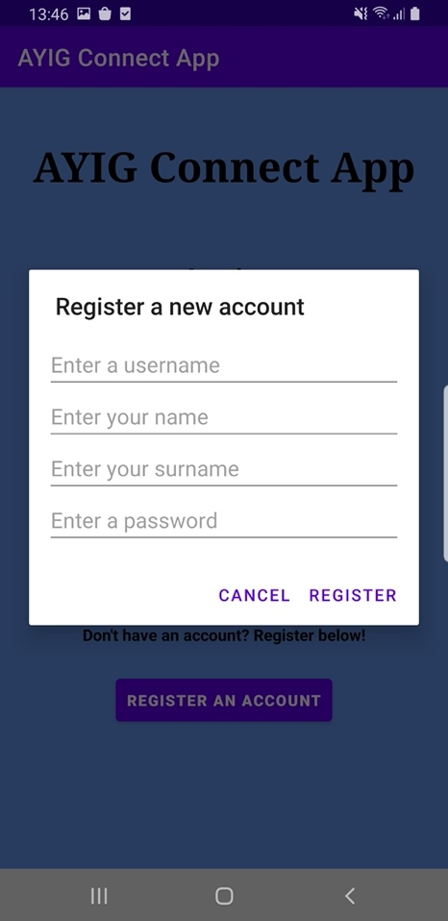

Figure 2.1 is the page that is presented to the user once they click on the register button. Here the user is instructed and required to fill in their account information.

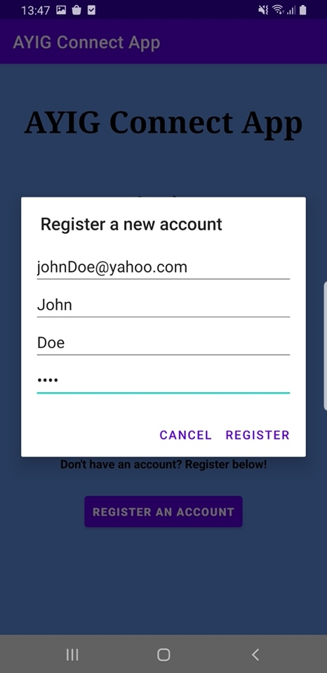

Figure 2.2 is a screenshot showing a user registering an account. The user has entered their details which are an email address, which is used as the username, the users name, the user’s surname and finally the user’s desired password.

Once the user has filled in their information, they are presented with 2 options. The user can either click on the register button to create the account or they can click on the “cancel” button to terminate the process.

**Figure 2.1) Register page**

**Figure 2.2) Register page with filled in information**

## Affiliate Page:

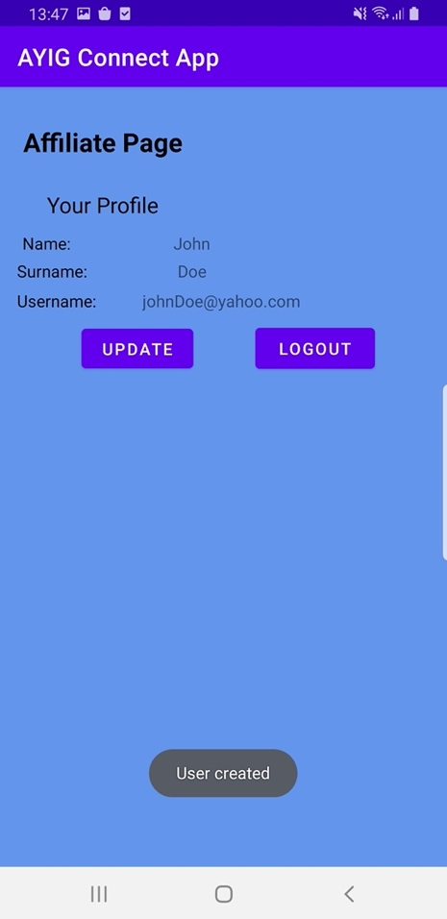

Once the user has been registered successfully the user is redirected to the affiliate page which can be seen in figure 3.1. A user is automatically an affiliate unless their role is changed by an admin. The user is prompted that their account has been successfully created.

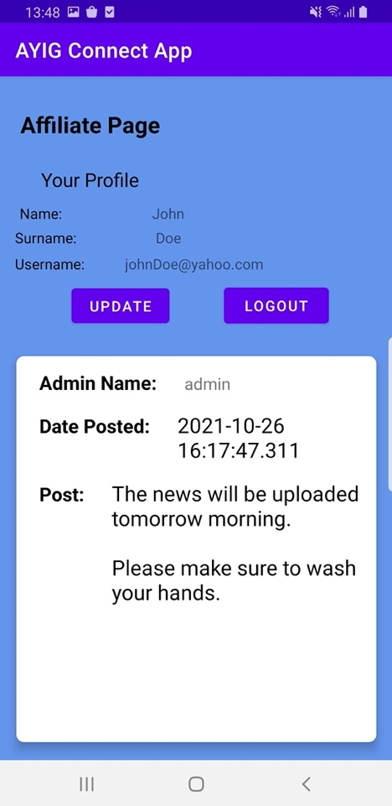

After the user has been prompted that their account has been successfully created they are presented with the updated affiliate screen which can be seen in figure 3.2.

The users account information is presented to them. The user has the option to update their account information by clicking on the "update" button or the user can logout by clicking on the “logout” button.

The user is also presented with post updates that have been made by the admins. The post consists of a post, the date at which it was posted and the name of the admin that had made the post.

**Figure 3.2) Affiliate page**

**Figure 3.1) Affiliate page**

## Update Page:

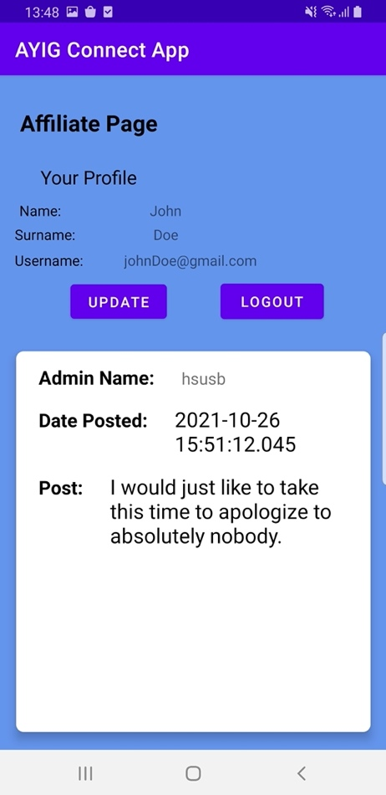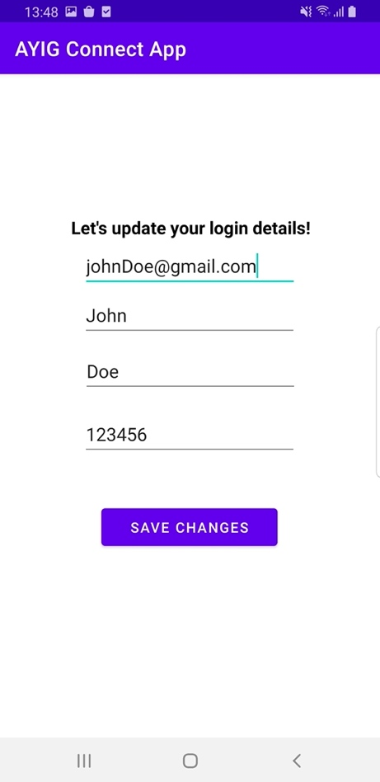

Once the changes have been made then the user is redirected to the affiliate page where the changes can be seen as shown in figure 4.2. We can see that the email address of the suer has been updated successfully.

**Figure 4.2) User changes saved**

Once the user has clicked on the update button to update their account information they are presented with the update page which can be seen in figure 4.1.

The following user has changed their email address from [JohnDoe@yahoo.com](mailto:JohnDoe@yahoo.com) to [JohnDoe@gmail.com](mailto:JohnDoe@gmail.com).

Once the user is happy with the changes they can click on the “save changes” button to save these changes.

**Figure 4.1) Update information page**

## Admin Page:

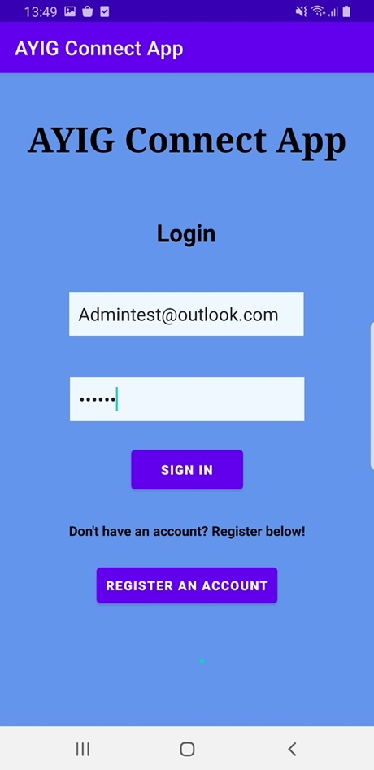

Figure 5.1 shows the details of an account that has the role of admin logging in.

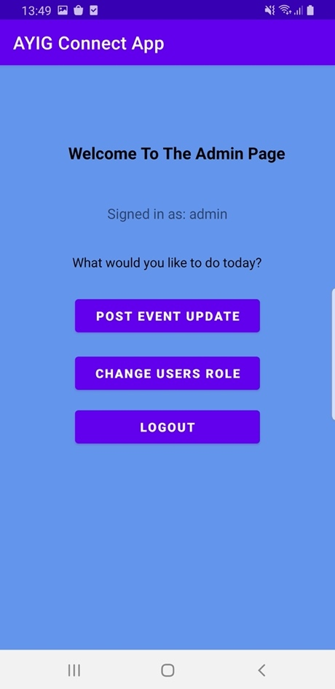

If the user is assigned with the role of an admin and they sign in, they are then directed to the admin page which can be seen in figure 5.2. The admin is welcomed and it displays the name of the admin, in this case the name of the admin is “admin”.

The admin can do one of three things, the admin can post an event update, the admin can change the role of the user from affiliate to admin and vice versa or they can logout.

**Figure 5.2) Admin page**

**Figure 5.1) Sign in as admin account**

## Change user role page:

Once the selected user’s role has been changed successfully, the admin is taken back to the admin page and has been prompted that the role of the user has been changed successfully, which can be seen in figure 6.2.

**Figure 6.2) Change user role page successful.**

If the admin clicks on the “change user role” from figure 5.2, then they are displayed with the screen which can be seen in figure 6.1. The admin can then click on the drop-down list and select the appropriate user which they would like to change the role of.

In this example we will change the role of the account we had created for John Doe which was seen in figure 2.2.

**Figure 6.1) Change user role page**

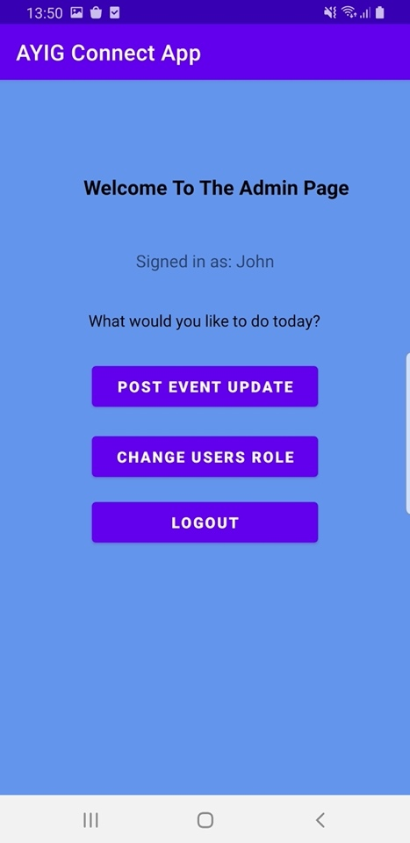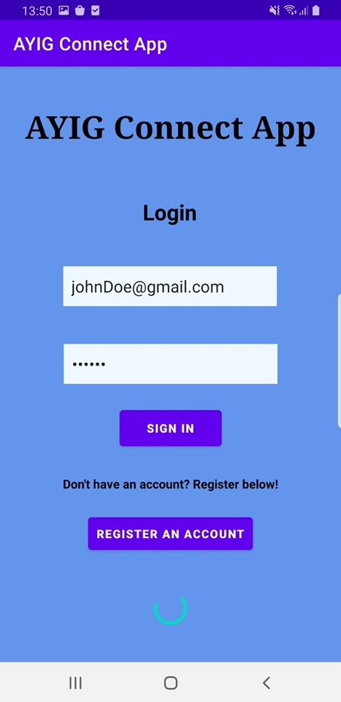

As seen in figure 6.3, John Doe has now been directed to the admin page because his role is now the role of admin.

**Figure 6.3)**

In figure 6.3 we can see that we are now going to sign in as John Doe which was the account we had registered in figure 2.2 and then changed the role from affiliate to admin which can be seen in figure 6.2.

**Figure 6.3) sign in as john**

## Post Update Page:

## 

Figure 7.1 shows the page where the admin is taken when they would like to post an update about an event. They can type the post in the text area given and then click on the “post update” button when they want to post what they have written.

## 

Once the post has been successfully uploaded the user is then directed back to the admin page and prompted with a message saying that the post has been successfully uploaded.

**Figure 7.2)**

**Figure 7.1)**

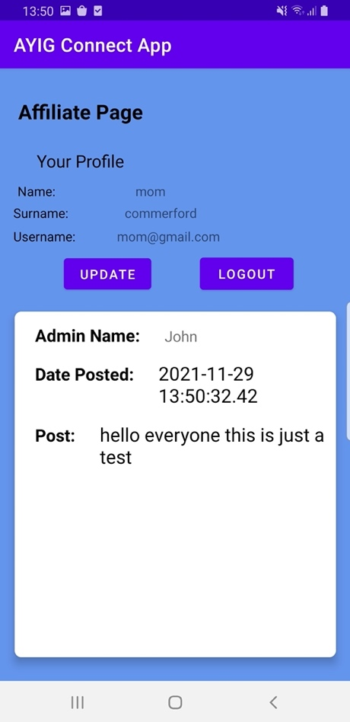

Figure 8 shows another affiliate that has then signed into the application and as we can see the post that was made by John Doe is displayed along with the other posts that can be seen if scrolled down.

**Figure 8)**

# Code Snippets

The following section will be used to display some of the code snippets from the various activities.

## Login And Registration Module

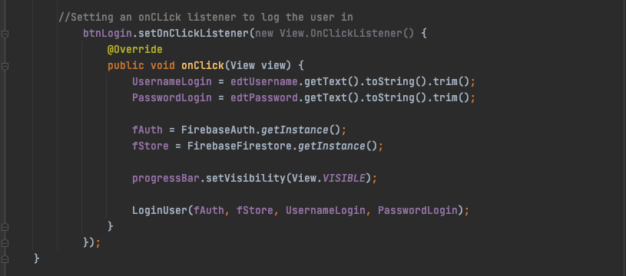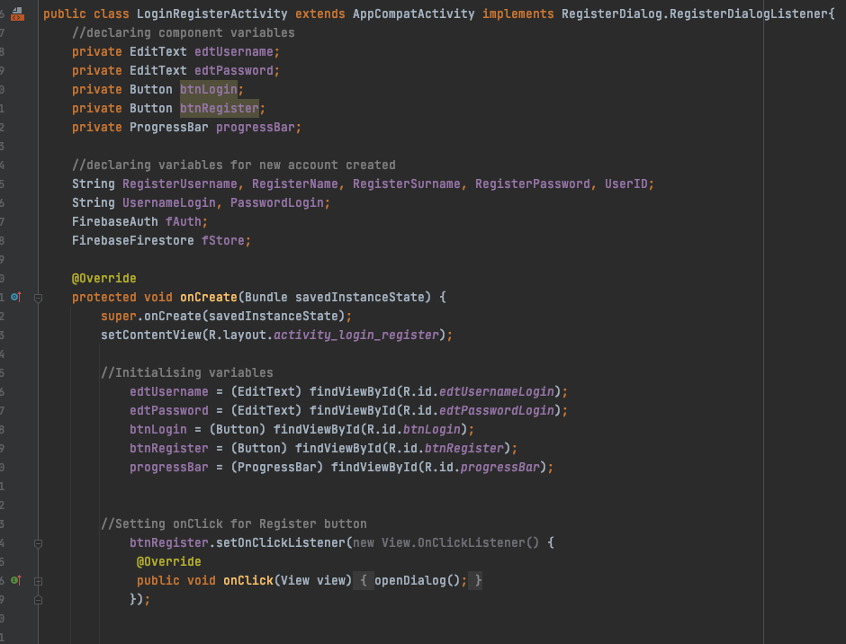

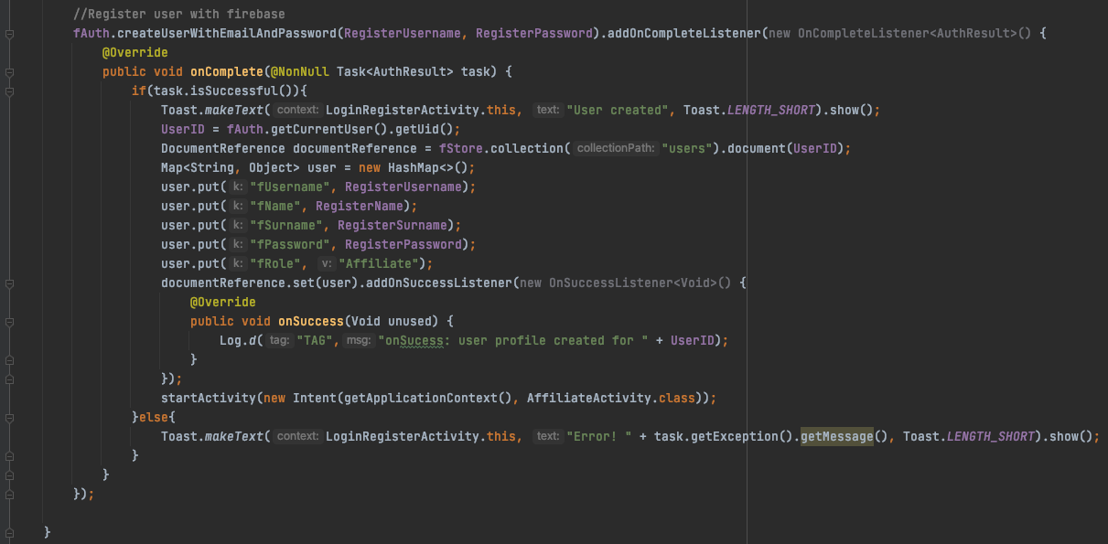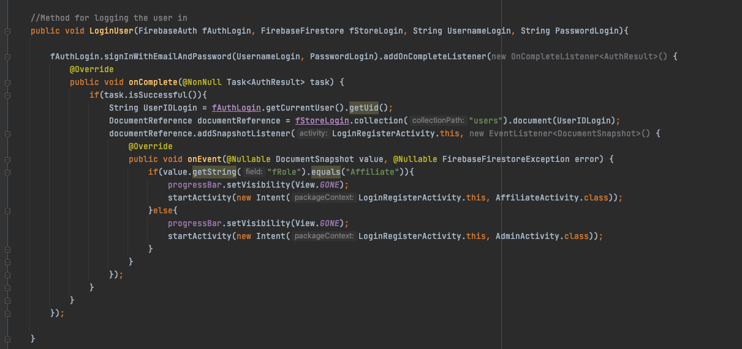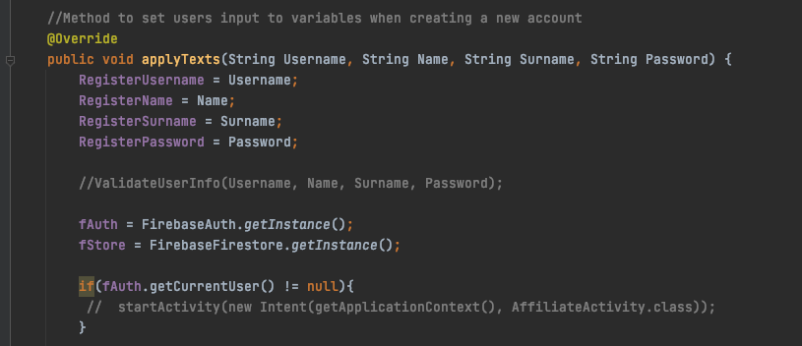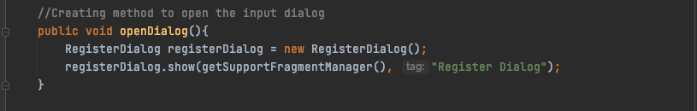

## Affiliate Module:

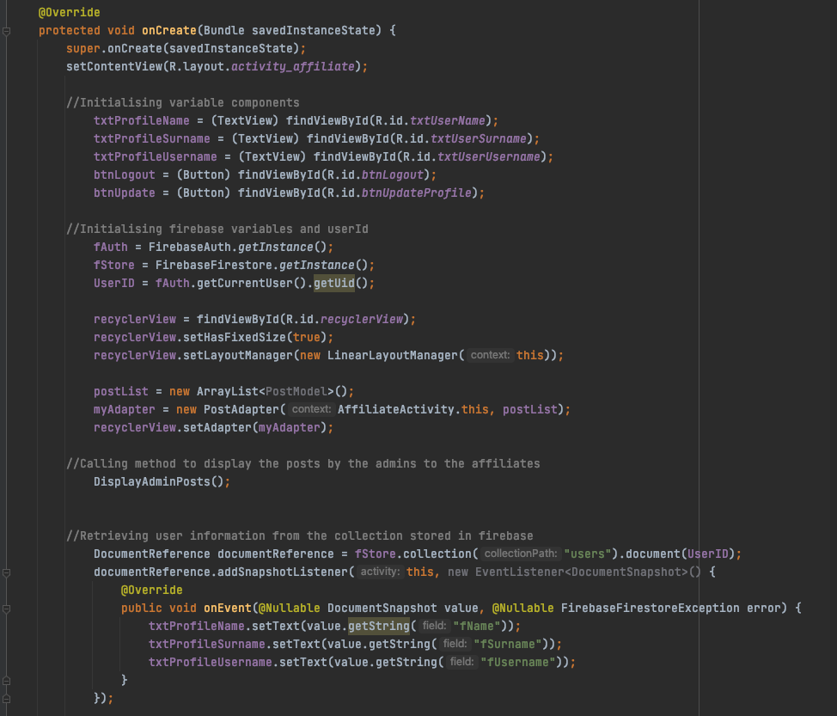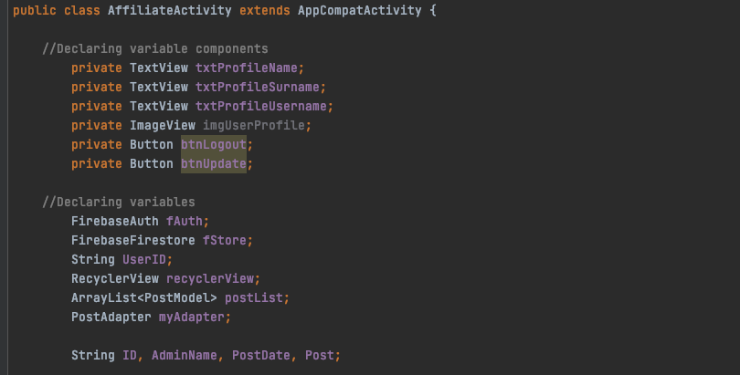

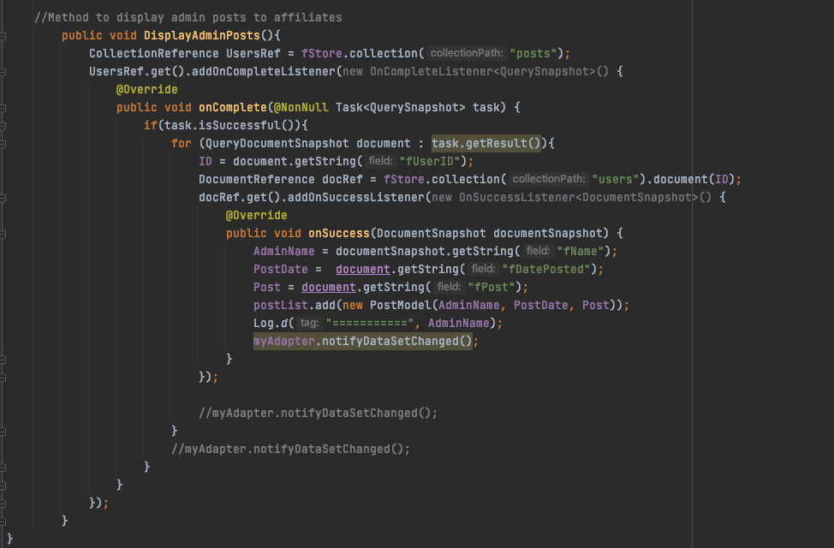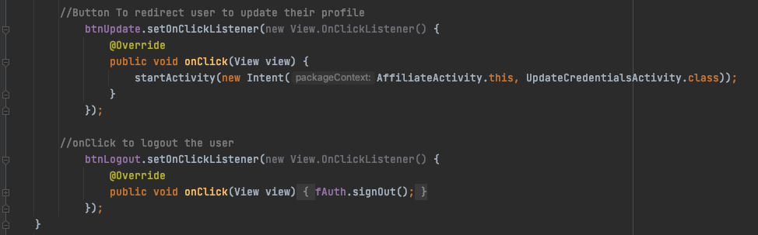

## Admin Module:

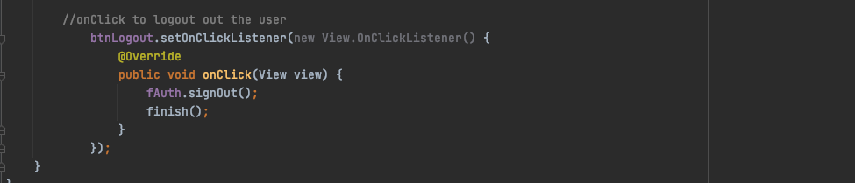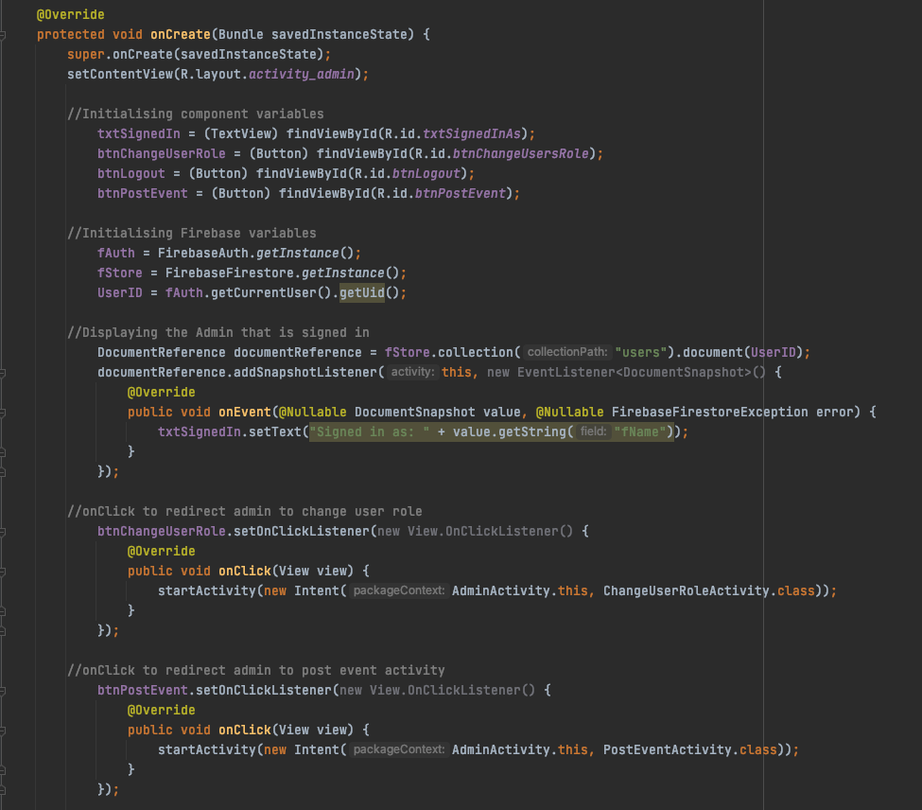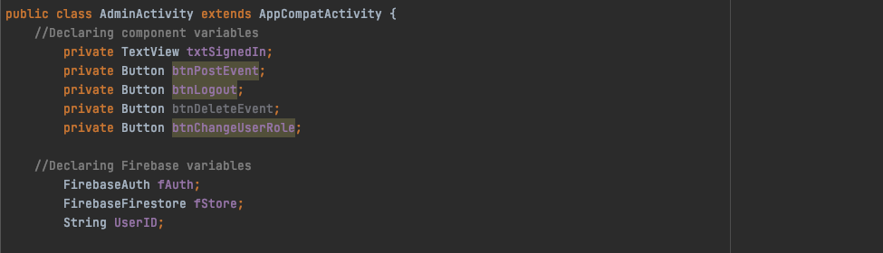

## Change User Role Activity

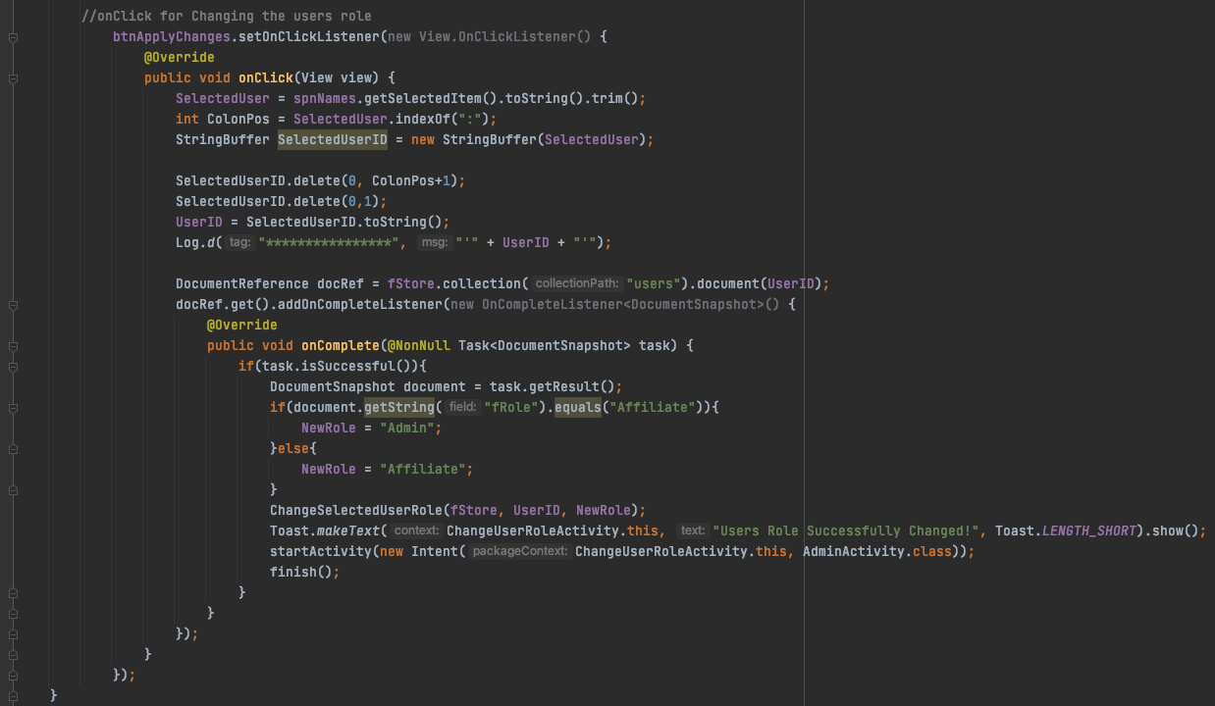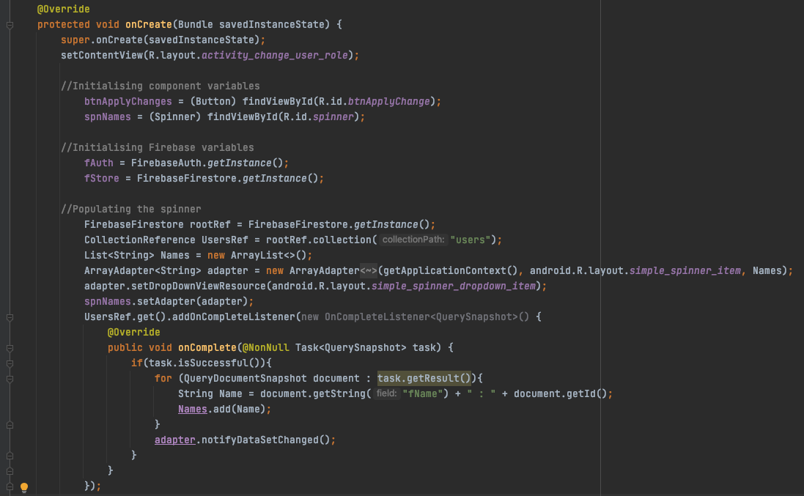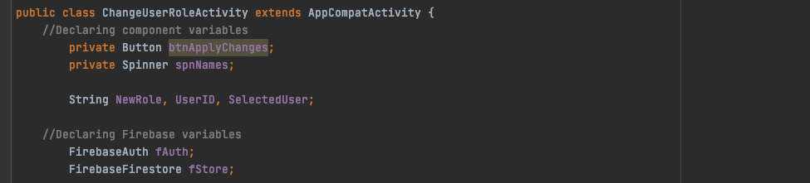



## Post Event Activity

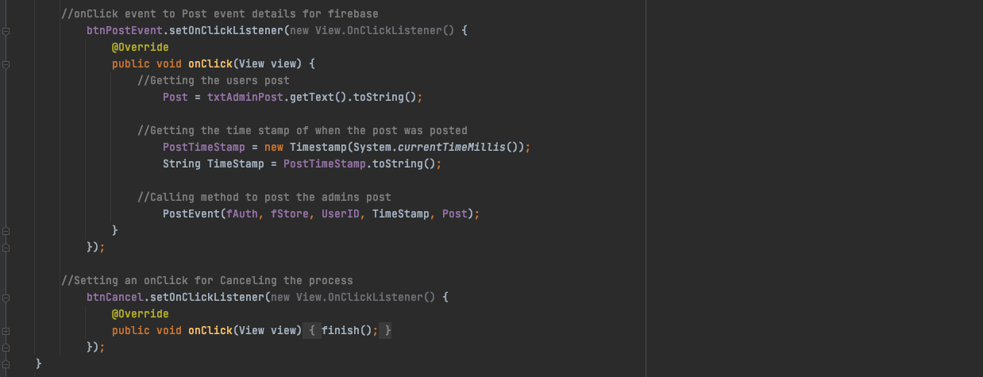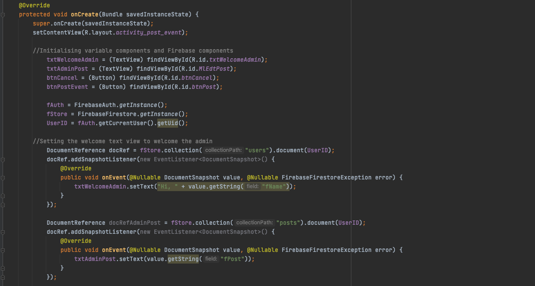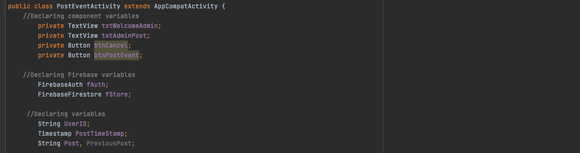

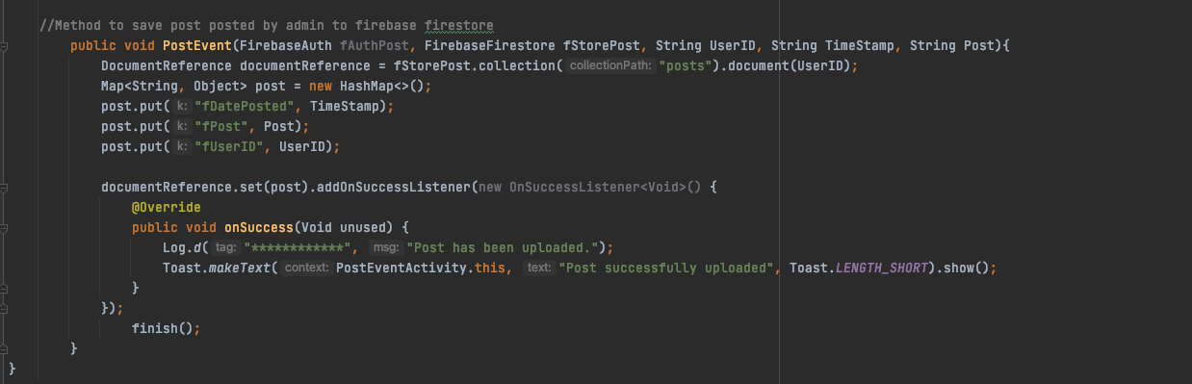

## Update Credentials Activity

## 

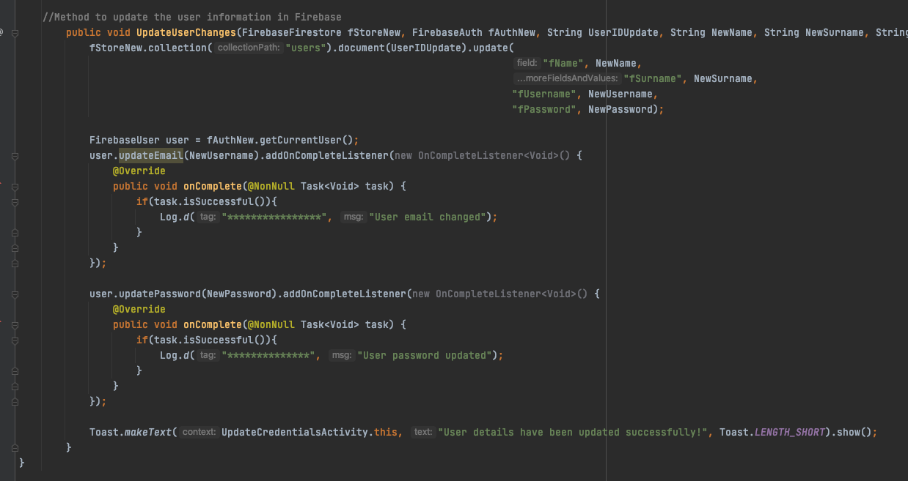

# Firebase:

## Authentication

## 

## Database

### Users table

### 

### Posts table

### 